Systems and Computational Biology Talks
Department of Systems and Computational Biology
School of Life Sciences, University of Hyderabad

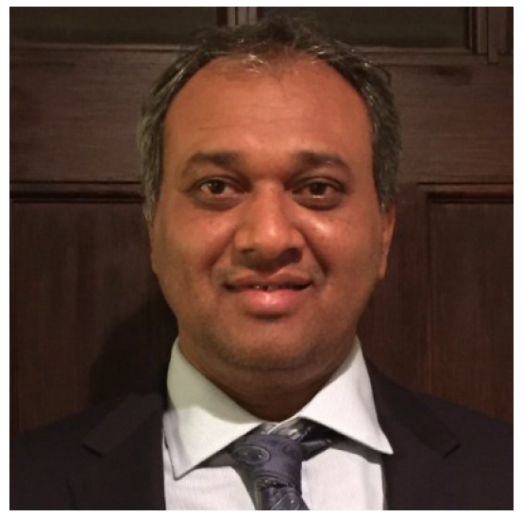
Extrachromosomal circular DNA drives oncogenic amplification

Dr. Pankaj Kumar
Department of Biochemistry & Molecular Genetics,
School of Medicine, University of Virginia, USA

22th July 2022, 11.00-12.00 noon
Seminar Hall, School of Life Sciences,
University of Hyderabad

Abstract: The ultra-high throughput sequencing methods are useful in generating large data sets to gain comprehensive insights into the cellular genomic signatures of tissues and cells. Here we describe a novel method for the identification of extrachromosomal circular DNA (eccDNA) from ultra-high throughput methods and a novel computational algorithm that can detect these circles at the whole genome level. The eccDNAs were discovered in normal cells, tissues, serum, plasma and cancer samples. Our preliminary results indicate that circles are a by-product of chromosomal Double-Strand Break repair. Longer eccDNA may harbor full-length genes, and in cancers, many oncogenes are amplified as eccDNA instead of getting duplicated on chromosomes. Gene amplification, specifically oncogene amplification, is frequently observed in cancers and is one of the major mechanisms through which new genetic material is generated. Many long circular DNAs are known to have origins of replication which get amplified in a cell. Most of the time these eccDNAs lack a centromere and are thus transmitted unevenly into daughter cells resulting in cell-cell heterogeneity.

The Speaker: Dr. Pankaj Kumar, a Computational Biologist by training, is the Director of the Bioinformatics Core at the University of Virginia and oversees the bioinformatics needs of the various departments under the School of Medicine. He has also been working as an Assistant Professor (2016-) in the Department of Biochemistry & Molecular Genetics, School of Medicine, at the University of Virginia. He has a master's degree in Life Sciences (JNU) and a Ph.D. in Computational Biology (CDFD). He was a Department of Defense Postdoctoral Fellow in Cancer Genomics for 2 years. His current research interests are in; 1) Studying Extrachromosomal circular DNA and 2) A novel non-coding RNA (transfer RNA fragments). He is an associate editor with the Genomics journal (for the last 5 years), a guest editor with PLOS Computational Biology and Ad hoc reviewer for Genome Research, Nucleic Acid Research, PLOS Computational Biology, Bioinformatics, Genomics, Database, Plant and Cell Physiology and iScience. He has been an Ad hoc grant reviewer with National Science Foundation (NSF, USA) and The Wellcome Trust-DBT Alliance. He has published 33 peer-reviewed articles including a first-author paper in Science, Science Advances and invited review articles in Annual review of genetics and Trends in biochemical sciences. He has two international patents: on eccDNA and Transfer RNA fragments. He is currently a co-investigator on grants to the University of Virginia Cancer Center (an NCI designated comprehensive cancer center) as well as on multiple NIH R01 grants.

